**Llanfair Primary School**



**Enjoy, Learn, Achieve**

**Mwynhau, Dysgu, Llwyddiant**

**School Prospectus**

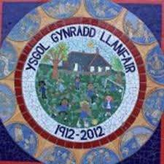

**Headteacher / Pennaeth: Mr. R. Jones**

**Deputy Headteacher / Dirprwy Pennaeth: Mrs J Shewell**

**Chair of the Governing Body: Mrs. M. Nelson**

**Welcome**

It is my pleasure to present the prospectus for Llanfair Primary School. Llanfair is an English medium, co-educational primary school with attached nursery, for children from 3 to 11 years of age. We are situated in the hamlet of The Herberts, adjacent to St. Mary’s Church, surrounded by stunning countryside views.

We provide a caring environment and a wide range of balanced learning opportunities for all children, to help them grow into independent and responsible people, well prepared for the next step in their school lives.

We believe that close co-operation between home and school is essential for children’s social and academic development. My staff and I are always available to talk to you about any aspect of your child's development.

Should you wish to discuss any area described within our prospectus further, please do not hesitate to contact school.

Mr. R. Jones

Headteacher

**School Aims**

At Llanfair Primary we aim to:

* Have high expectations where everyone strives to do their best.
* Encourage children to think, ask questions and be creative through challenging, interesting and fun learning.
* Ensure each child is successful; ready to learn throughout their lives and flourish in the future.
* Develop each child’s resilience, self-belief and confidence to seek out, relish and overcome challenges.
* Develop caring, considerate and compassionate children, with a strong sense of belonging and heritage, who use their power positively to change the world.

**Contents:**

**Section 1: Contact details and location p 4**

**Section 2: Admissions p 6**

**(Inclusive of secondary school arrangements)**

**Section 3: School Day Organisation p 7**

**(Inclusive of times, uniform, school dinners).**

**Section 4: Curriculum and Teaching p 13**

**(Inclusive of homework, P.E., R.E. and Collective Worship).**

**Section 5: Safeguarding and Site Security p 17**

**Section 6: Additional Information p 17**

**Section 1: Contact details and location**

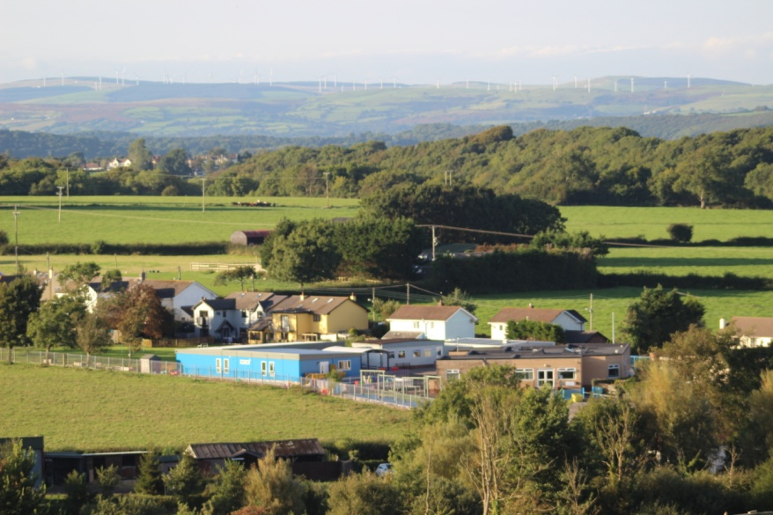

The Herberts, St Mary Church

Cowbridge,

Vale of Glamorgan.

CF71 7LT

Tel: 01446 772245

Email: [LlanfairPS@valeofglamorgan.gov.uk](mailto:LlanfairPS@valeofglamorgan.gov.uk)

[**www.llanfairps.com**](http://www.llanfairps.com)

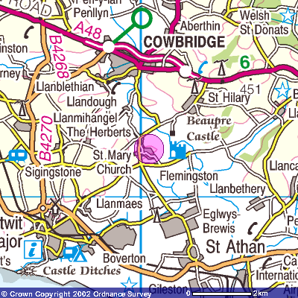

A Satellite Navigation system will take you to the Church in the main village of St. Mary Church; the school is not in the main village, it is in the hamlet sign-posted The Herberts.

At The Herberts, take a left turn on the corner of the right hand-bend. A sign indicates the school’s location.

**Our school community**

|  |  |
| --- | --- |
| **Class teachers**  Mrs. Gaisford  Mrs Shewell  Mrs. Kumar  Mr. Lewis  Mrs. Norris  Mrs. Mayes  Mrs. S. Trigg | **Governors**  Mrs. N Sturgess– Clerk  Mrs. M. Nelson – Chair  Mrs. C. Neuddeg – Vice Chair  Mrs. N. Russ  Mr. I. Purdy  Mrs. M. Llewellyn  Mr. G. Smith  Mr. S. Trigg  Mrs. S. Trigg - Teacher representative  Mr. A. Crowe  Mrs. A. Adams  Vacancy - Non-teaching Representatives |
| **Learning Support Assistants**  Mrs. Davies  Mrs. Evans  Miss Jones  Miss Walker  Mrs. Earey  Mrs. Downie |
| **Ancillary Staff**  Mrs. A. Foulkes– Administrative Officer  Mr. M. Thomas – Caretaker  Mrs. N. Cook – School Cook  Mrs. Gilvear – Breakfast/Kitchen  Mrs. Duncan - Breakfast  Miss Walker – Breakfast |

**Section 2: Admissions**

Application to attend Llanfair Primary School is through the Vale of Glamorgan Local Education Authority, address:

Civic Offices,

Holton Road,

Barry,

CF63 4RU

or click on the link:

<http://www.valeofglamorgan.gov.uk/en/working/education_and_skills/schools/admissions/school%20admissions.aspx>

Llanfair Primary School’s catchment area serves the villages of Llandough, St. Mary Church, St. Hilary, Llantrithyd and Llanblethian.

Subject to places being available at the school children may be admitted from outside the official catchment area. Indeed, many children come from the outlying villages/towns of Cowbridge, Llanmaes, St. Athan, Sigingstone, Llantwit Major, Llandow, Eglwys Brewis, Boverton and Flemingston. The intake figure per year group is 20.

Children are accepted into the Nursery at the beginning of the school year in which they reach the age of four or the term following their 3rd birthday, depending on numbers of children already in the Nursery. They may then apply to join our Reception class the following year. The children transfer to Secondary Education in the September following their eleventh birthday. Many Llanfair pupils transfer to Cowbridge Comprehensive.

**Transfer to Comprehensive School**

At the end of Year 6, children normally transfer to Cowbridge Comprehensive School Parents will receive forms so that they can apply for this transfer if they so wish; however they can choose to apply for them to attend another of the County's secondary schools.

Prior to transfer, children visit Cowbridge Comprehensive where they meet their new teachers and get to know the school. There are opportunities for our Year 6 children to take part in transition sessions to help their move into year 7.

**Section 3: School Day Organisation**

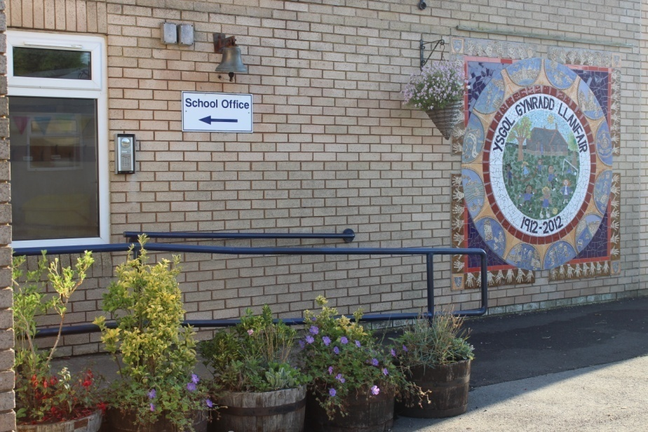

The school day is separated into a morning and afternoon session. The school session times are as follows:

**Nursery:** 9am – 12.00pm

**Foundation Phase:** Morning session 9am – 12pm

Afternoon session 1.00pm – 3.15pm

**Key Stage Two:** Morning session 9am – 12.20pm

Afternoon session 1.15pm – 3.30pm

School gates open at 8.50am and school begins promptly at 9am. We expect all pupils to arrive punctually. Registration closes at 9.30am. Any child arriving after this time will be marked as absent for the morning session. Afternoon registration closes fifteen minutes after the session begins.

The external **pedestrian gates are locked** from 9.00 until 3.10pm. If you require access to the school when the gates are closed please phone when you reach the gates.

School term dates for the current year can be found in the appendix or at the following link:

<https://www.valeofglamorgan.gov.uk/en/living/schools/School-Term-Dates.aspx>

**Attendance**

High levels of attendance are essential to children’s academic and social development. If your child is going to be absent you must inform the school ***on the first day of absence***, before 9.30am.

Please give prior notice to the school office of hospital, doctor, dentist, optician appointments etc.

Parents are requested to arrange their family excursions within the school holidays so that a child’s education is not disrupted.

Parents who do take their children on holiday during term-time must complete a form stating reasons for their decisions.

Pupils’ attendance is monitored carefully and parents are regularly informed of their child’s attendance rate.

For further information, please see the school’s Policy for Attendance, available from the main office/website.

**Illness**

Pupils should attend school whenever possible but obviously, if they are ill they should be at home.

For illnesses we use the guidelines from the Health Protection Agency to decide whether or not children and adults with varying conditions should attend school.

If a child recovering from an illness is well enough to attend school but requires medication, this should be handed in at the main office, with a completed form (available from the school office/website). Further information can be found under the medicine section below.

In cases of head lice infestation, the school takes a strict line; children be treated with the correct medication. When there is an identified case in the class, all parents will be informed via text message and are asked to check their child’s hair, treating them as necessary.

**First Aid**

School staff have received First Aid training and administer this accordingly. A record is kept and note is provided to inform parents. When a child has a head bump, a text message is sent to parents.

School submits incident and accident forms to the Local Authority as required.

**Medicines**

The school’s Healthcare Policy is available on the school’s website. This details arrangements for parents requesting administration of medicines to their child by school staff. This includes the administration of liquid paracetamol and asthma inhalers.

Please note:

• Parents must complete a request form prior to sending any medicines to the school with a child. This form is available from the office or can be downloaded from our website.

• Any medicines must be brought in a sealed, unbreakable container with clear instructions as to the dosage and when they are to be administered. In the case of certain medicines, the Headteacher might ask for GP guidance to accompany them.

• No child is to keep any medicines on their person or in their tray or bag. All medicines must be given to the Admin officer who will ensure that they are kept in a safe place, and administered at the proper times.

We always do everything in our power to ensure that the children's health does not suffer in any way, and I would ask parents to follow the above procedure. We will share information with staff regarding your child’s medical condition as required. We may also sensitively display key information in classrooms to ensure all staff are aware of your child’s condition and how to treat if necessary.

**N.B.: *No medicine will be administered without the above procedure being followed.***

If your child is taken ill, or has an accident in school, you may be contacted via emergency telephone numbers and asked to collect.

**Morning arrival and collection arrangements**

We are a rural school that benefits from a large car park, however it can become congested. To ensure the children’s safety, we have several procedures in place and ask parents to support these.

We operate a drop off system in the morning. Parents can parallel stop their car on the right hand side of the car park to allow children to step onto the path and make their way onto the school yards. It remains the responsibility of parents for their child’s transfer to the yard safely.

The school gates open at 8.50am. Nursery children can be dropped off at this time at the classroom. Please do not allow your child to arrive earlier than this time.

Where a parent needs to accompany their child to the yard, please use the spaces on the left hand side and reverse park.

Please drive slowly in the car park at all times.

At the end of the school day, parents collecting only Foundation Phase pupils do so at 3.15pm. Key Stage Two children finish at 3.30pm.

We ask parents collecting children at 3.30pm to avoid arriving in the car park before 3.25pm.

All parents are to vacate the car park promptly to ensure safe arrivals and departures.

**If someone different is collecting your child please ensure that you inform school.**

**School Meals**

Children from Reception age onwards stay during the lunch break. The children bring a healthy packed lunch or have a school dinner.

Big Fresh Catering Company provide a healthy nutritious school meal at lunchtime, which is compliant with the food and nutrient standards set by the Welsh Government.

All kitchen staff are trained in accordance with the legislative requirements associated with catering procedures, to certify that food is prepared in a protected environment.

Each day there is a choice of the cooked meal or seasonal alternative (including sub-rolls and baked potatoes). All served with a dessert and water.

**Snack**

Children are encouraged to bring a fruit snack for the morning break and a water bottle. Drinking water is available at all times in the main entrance.

Staff will inform nursery parents of the arrangements for snack.

**Welsh Government Breakfast**

The school operates a breakfast provision from 8.00am each day. Parents that wish to use the club need to inform school and complete a registration form. While in breakfast club the children are provided with a healthy breakfast choice. They transfer to their classes for the start of the day.

**After-school Care**

An externally run after-school child care provision runs on-site.

*‘At Vale Play we provide high quality childcare ensuring both child and parents are happy. Our after school club in Llanfair offers a relaxed, fun, happy environment where children can unwind after a day at school. Children are listened to, appreciated and recognised in their efforts and achievements. We promote security, self-esteem and to help children develop confidence, warm and positive relationships. Children enjoy being with other children and thrive in their company*

*All our staff go through vigorous checks, such as references, health, DBS and policy and procedure training. Kara Oakley and Kirsty Clarke are the Directors and Managers of the after school and also run two out of school clubs in Penarth.*

*You can email, phone or text for more information. We are based in the canteen part of the school and have an open door policy and welcome new families in at any time. Vale Play also have a facebook page which we update regularly. Please search ‘Vale Play’ and ‘like’ our page for regular updates.*

*Email* [*Llanfair@valeplay.co.uk*](mailto:Llanfair@valeplay.co.uk) *Phone 07955527631*

*We look forward to meeting you and your child.’*

**School Uniform**

The school uniform creates a sense of belonging and a feeling of pride in the school.

***We strongly encourage everyone to wear it.***

* Royal Blue Sweatshirt/Cardigan with school emblem
* White or Royal Blue Polo Shirt
* Grey Trousers/Shorts/Skirt/Pinafore Dress/ Blue and white checked or striped dress
* *Embroidered Navy Ski Hats are available from the school.*
* *Shorts/tracksuit bottoms, trainers or plimsols and t-shirt for PE. House t-shirts are available.*

**Please ensure that all items of clothing are clearly labelled/marked with the child's name.**

Sweatshirts, cardigans and polo shirts which include the school’s emblem can be purchased from L M Sports in Llantwit Major or the Pencil Case in Cowbridge. You may, if you prefer, buy uniform of the correct colour from any retailer.

Each child is allocated one of three houses; Glyndwr, Caradog or Llewellyn. They participate as part of these houses at events throughout the year. P.E. t-shirts in House colours and printed with the House names are available from the School Office costing £8.50.

**Jewellery**

Items of jewellery such as rings, bracelets, necklaces etc. must not be worn during school time. Girls and boys with pierced ears should only wear the smallest stud ear-rings possible and these should be removed during PE and Games lessons.

**Communication**

We use a range of methods to communicate with parents including regular newsletters. We use a **Text** service to keep parents informed of activities and updates. We use **Teachers2parents** to send newsletters and provide hard copies when needed.

Our website is updated on a regular basis with all the latest news and information.

To adhere to GDPR we will ask for your consent to receive our emails. Further information can be found in our privacy notice on our website.

Please ensure that you alert school of any changes to your contact details.

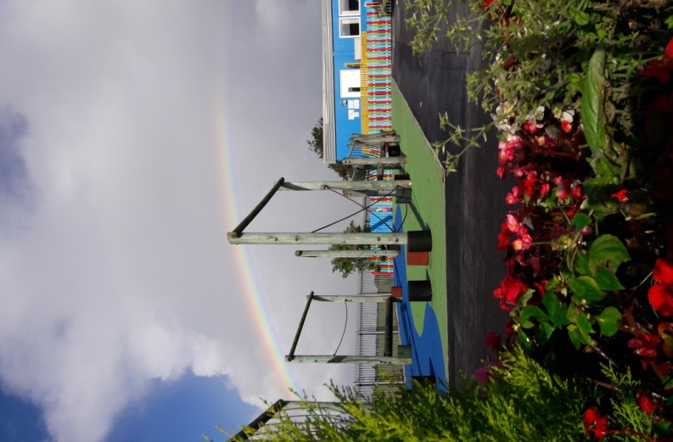

**Section 4: Curriculum and Teaching**

The curriculum at Llanfair Primary School is broad and balanced based on the New Curriculum 2022. The curriculum is organised into programmes of learning known as schemes of work. Our schemes of work focus on the development of skills and knowledge at the right stage for each pupil.

The school aims to provide the highest standards of teaching that will engage all the children in their learning. We provide a wide range of learning experiences that will develop both the children’s academic abilities and their social and emotional development.

Teaching at Llanfair takes a range of forms from whole class lessons to small groups and individuals. At every stage the learning is adapted to ensure that the work is suitably challenging.

Extra arrangements for children with Additional Learning Needs ensure that they are very well supported.

The children are grouped into three Foundation Phase classes and three key stage two classes. Some classes are of a mixed age range. Splits in year groups are made purely on age. The organisation of the classes may change from year to year.

**Religious Education and Collective Worship**

The school uses the locally agreed curriculum for Religious Education. Christianity, Judaism and Islam are the main religions studied but during specific festivals and across other subject areas other religions may be studied.

A daily act of Collective Worship is held in school for all pupils. The themes for collective worship are broadly Christian in nature and are often based on a set of values that the school encourages within the children. The values that are planned over a two year cycle. There are five core values that the school promotes. These are:

respect, caring, honesty, perseverance, cooperation

Usually a story or video is used and the children are invited to engage in quiet reflection and join a prayer if they wish. The school also holds celebrations at various times of the year such as Harvest and Christmas.

A celebration assembly is held on Fridays. At this assembly the children are invited to explain any events they have participated in outside of school or any awards they have attained (dance shows, sports awards etc.)

Parents have the right to withdraw their child from religious education lessons and collective worship and should contact school to discuss this matter.

**Welsh**

Welsh plays an essential part in preparing our pupils for living and working in Wales and is an integral part of the National Curriculum. We aim to promote a strong Welsh ethos and provide enriching activities that make learning Welsh enjoyable. We also provide opportunities to celebrate and explore the culture and heritage of Wales in order to develop awareness of the special nature of our country.

**Physical Education**

P.E. is a compulsory element of the National Curriculum except for those pupils permanently excused on health grounds. Such cases must be supported by a medical note from your G.P. Children suffering minor ailments will be excused when parents request it, but we would greatly appreciate a brief explanation in writing.

P.E. lessons are twice weekly for all classes either in the school hall or outside. **Children need to have their own P.E. Kit - T shirt (House colours are available), shorts and trainers or plimsolls (any colour). They should bring this at the beginning of the week. Class teachers will inform parents of their classes’ PE days at the beginning of the year.**

House T Shirts are available to order from the school. Tracksuits may be worn during the winter months.

**Aims**: Through our teaching of Physical Education our aims for the children are to:

* Promote positive attitudes towards health, hygiene and fitness.
* Develop a sense of fair play and sportsmanship.
* Explore dance and gymnastic movement ideas imaginatively, including actions, dynamics, space and relationship.
* Organise and use equipment safely and correctly.
* Improve swimming ability and confidence in the water.
* Use common skills effectively in different types of game, adapting their technique and style to suit the needs of the game.
* Have opportunities to play against other schools in a variety of sports.

**Sex and Relationships Education**

Sex and relationships education is integrated into the curriculum. For younger children it will naturally arise when they question values and attitudes which concern aspects of family life, personal relationships, caring for others and growth and development. For the older pupils, lessons focusing on issues surrounding puberty and relationships will be taught sensitively. Parents are informed when these lessons are taking place

**Additional Learning Needs and Looked-After Children**

We are an inclusive school at Llanfair. Children with additional learning needs, including more able and talented pupils and looked-after children, are given individual attention within the classroom situation and learning provision appropriate to their needs.

Learning Support Assistants provide individual and/or group support in collaboration with the class teachers. Intervention programmes include Catch-Up Literacy, Trugs, Every Child Counts (maths). We stress the importance of involving parents at every level of their children’s education and identifying a child’s special needs at an early stage.

**Mrs. Hayley Mayes** is the school Additional Learning Needs and Looked-After Children Coordinator.

There is also a register for more able and talented children (MAT). The progress of these children is monitored by the MAT Co-ordinator **Mrs Amy Kumar**.

**Service Children**

If your child is classed as a Service child please ensure that you inform school as we may be able to offer additional academic and social support when required. A service child is defined as:

* A child who has one or more parents currently serving in the armed forces
* A child whose parent/s have served in the armed forces within the last six years (Veteran)
* A child whose parent/s are currently serving as Reservists.

**Homework**

School provides homework that is designed to support the children’s learning without being onerous.

In Nursery, homework focuses on topic work and book bags are available for parents to borrow. From Reception to Year 2 children receive either literacy or numeracy homework on Fridays and a reading book.

The reading book continues as homework in Key Stage 2. In addition, children from Year 3 to Year 6 receive a Learning Log in which topic based homework is given on Fridays for return by the following Wednesday.

Key Stage 2 children also receive spellings on a Monday to practise in preparation for a test on Fridays.

We also use the Welsh Government Digital Platform Hwb for completing homework tasks throughout the school.

**Reporting to Parents**

Parents’ evenings are held twice a year in the Autumn and Spring Terms. We hold a Tray and Display afternoon during June/July where children sit with parents and talk about their work.

Appointments are made for parents to discuss their child’s progress with the teacher. An annual written report is sent out to all parents, usually in early July.

If there are problems at any time, it is advisable to contact the class teacher immediately, rather than wait for a parents’ evening. Serious matters should always be referred to the Headteacher.

**Extra-curricular activities**

A range of extra-curricular activities take place throughout the year. These vary from term to term. Activities include; orchestra, netball, dance, football, chess, gardening club. Information about these activities is shared through the newsletters.

An externally run art club runs on Thursdays immediately after school. Please contact school for further information.

**Music Tuition**

Cardiff and Vale Music Service provide music tuition within school. Information about the current range of lessons available can be sought from school. Music tuition fees are payable direct to Cardiff and Vale Music Service.

**Section 5: Safeguarding and Site Security**

The safeguarding and wellbeing of our pupils is paramount. The school has a comprehensive Safeguarding Policy which is available from the school and on our website. The school fulfils its legal duties and liaises with external agencies as necessary. All staff receive annual training in Safeguarding which covers Child Protection. Our Designated Senior Person is Mr R Jones. Mrs J Shewell and Mrs. H. Mayes are our Deputy Senior Persons.

Our Safeguarding Governor is Mr D Davies.

During the school day the pedestrian gates are locked. The classroom buildings are opened using a key fob system.

School adheres to the local authority’s Safer Recruitment Policy.

**Discipline and Behaviour**

At Llanfair Primary School we believe that children attend our school to develop not only their academic skills but also their social and emotional skills. Learning how to manage their behaviour, responses and actions is part of this learning. We want our children to develop many attributes; however we identify the following as the core values:

respect, caring, honesty, perseverance, cooperation

Our rules underpin the development of these values. There are three to aid the recall of these rules by all school community members and to allow reference to the rules when discussing behaviour with children.

Be ready, Be respectful, Be safe

We aim to recognise children that adhere to the school rules. There will be times where children will fail to adhere to the rules and a tier of consequences exists for these occasions.

If on the rare occasion an incident is of a more serious nature, the parents will be informed in order to enlist their support in dealing with the matter.

Further information can be found in the school’s behaviour management policy available on the school’s website.

**Section 6: Additional Information**

**Parental Involvement**

Several volunteers are involved with various activities in school and their contribution is invaluable.

If at any time you wish to offer your help, please contact the Headteacher as your support is always much appreciated.

In order to comply with current requirements, all adult helpers are subject to the Safer Recruitment Policy and associated checks and references.

**Parent - Teacher Association**

Llanfair Primary School has a very active P.T.A. that organises many fund-raising activities throughout the year and raises a great deal of money for purchasing items needed by the school.

All parents are most welcome to get involved and their support is much appreciated. A particular welcome is always extended to new parents.

Details of PTA meetings are published in newsletters and the PTA has a Facebook page.

**Charging for School Activities**

All activities offered wholly or mainly during normal teaching time are available to every pupil, regardless of their parents’ ability or willingness to help meet the cost. No charge will be made for the cost of teaching materials, books or other equipment.

The school retains the discretionary right to charge for optional extras involving individual tuition, e.g. music lessons.

The school also reserves the right to invite voluntary contributions in support of the cost of providing any activity organised by the school, whether during or outside school hours. Where an activity is dependent on a sufficient level of contributions, the school has the right to cancel the activity, if insufficient support is received.

The school retains the right to request parents to pay for the cost of damage or loss caused by their child.

Classes are taken on visits that are of educational and social value to the children.

This ranges from visits to museums, industry, castles and other places of historical interest to attendance at an outdoor pursuit residential, swimming and leisure activities. Due to the location of the school we always need to charge for coach hire.

Further information can be found on the website in our Charging and Remission Policy.

**Equal Opportunities Statement**

Llanfair Primary School is fully committed to equality of opportunity in education. At Llanfair Primary School, discrimination of any kind and on any basis is unacceptable.

It is the policy of the school to ensure equality of opportunity for all its pupils, parents, employees and governors, irrespective of race, ethnicity, nationality, colour, cultural background, language, religious beliefs, gender, marital or parental status, social class, sexual orientation, disability, age, HIV or AIDS status and any other grounds or conditions which cannot be shown to be justifiable.

**Complaints Procedure**

Occasionally there may be times when you have a concern or issue that you wish to raise. We would welcome the opportunity to deal with this matter and ask that you contact school as soon as possible. A parents’ first point of contact is the classteacher.

A copy of the full complaints procedure is available from the Headteacher and on the school website.